- The Monetary Policy Committee voted 7-2 to cut Bank Rate by 25bps to 4.5% at its February meeting. The MPC's core message was that it expects a "gradual and careful" loosening of policy, but heightened uncertainty means a wide range of outcomes are possible.
- The minutes and Monetary Policy Report offered mixed signals about the policy outlook. The MPC published a much weaker forecast for GDP. But even factoring in much higher interest rate assumptions, the MPC's inflation forecast takes nearly three years to get back to 2%. This suggests the MPC thinks the growth-inflation trade-off has worsened significantly.
- We maintain our forecast that the MPC will cut Bank Rate by a further 75bps in 2025. The MPC emphasised that the risks to their growth and inflation forecasts are two-sided. But we see the risks as being skewed towards a faster pace of cuts, in response to weak activity.
The Bank of England's Monetary Policy Committee voted 7-2 to cut Bank Rate by 25bps to 4.5% at today's meeting. The two dissenters – Swati Dhingra and Catherine Mann – voted for a 50bp cut. Mann's vote was particularly surprising given she had previously been the most hawkish members of the committee. But the minutes suggest that Mann's vote was motivated by wanting to send a signal to financial markets – she still appears concerned about inflation persistence and expects Bank Rate to "stay high".
In the minutes from the December meeting, the MPC had signalled a change of tack, with the weakness of activity and employment playing a larger role in the Committee's deliberations. The February meeting built on this theme, but the emphasis was less on the implications of weak demand, and more on the interaction with supply and inflation persistence.
The MPC slashed its forecast for GDP growth in 2025 to 0.7% from 1.5%, reflecting both the carry-over effect of the poor performance at the end of last year and a downgrade to its projections for H1 2025 (Chart 1). It judges the probability of negative year-on-year GDP growth is roughly 40% for both Q1 and Q2. But the results of the MPC's annual supply-side stocktake concluded that potential productivity growth has been weaker than previously anticipated, meaning that very little spare capacity has emerged.
Chart 1: The MPC's new growth forecast is much weaker for 2025
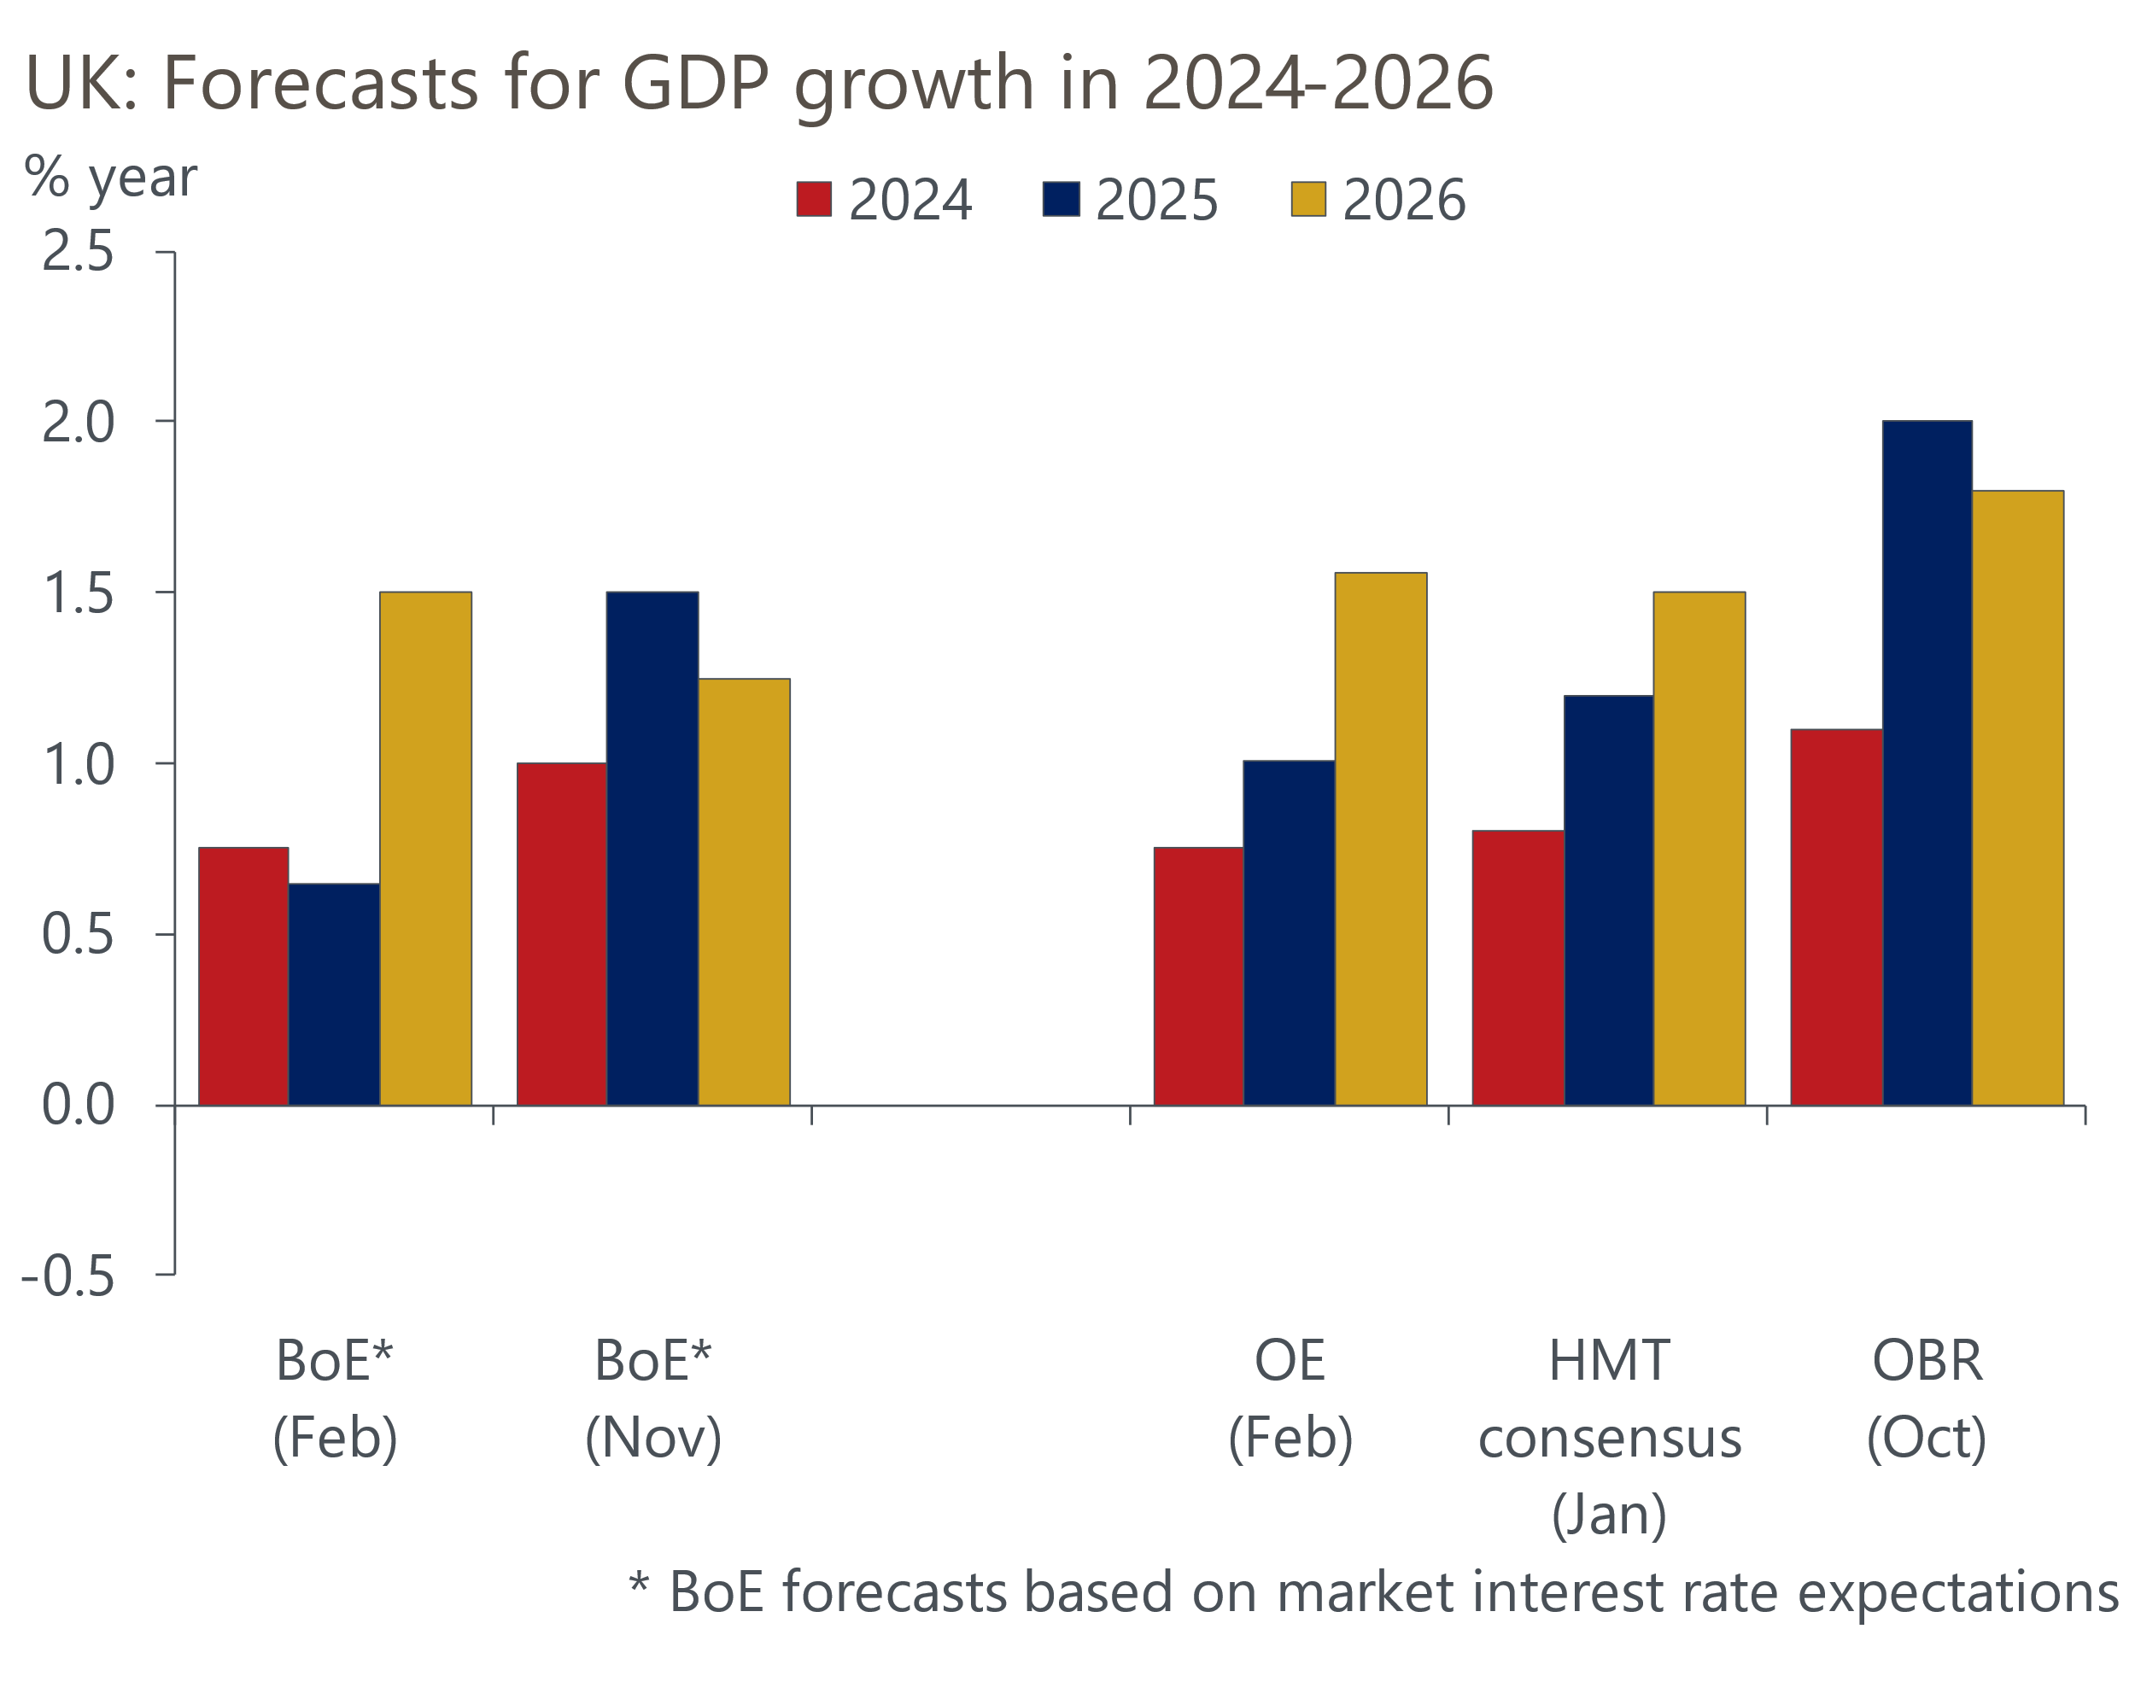
Sources: Oxford Economics, BoE, HMT, OBR

The combination of scant spare capacity, a higher assumption for energy prices, and a weaker profile for sterling meant that the MPC raised its 2025 inflation forecast by 0.75ppts to 3.5% (Chart 2). This is higher than even our above-consensus forecast.
Chart 2: The MPC expects getting inflation back to target will take nearly three years
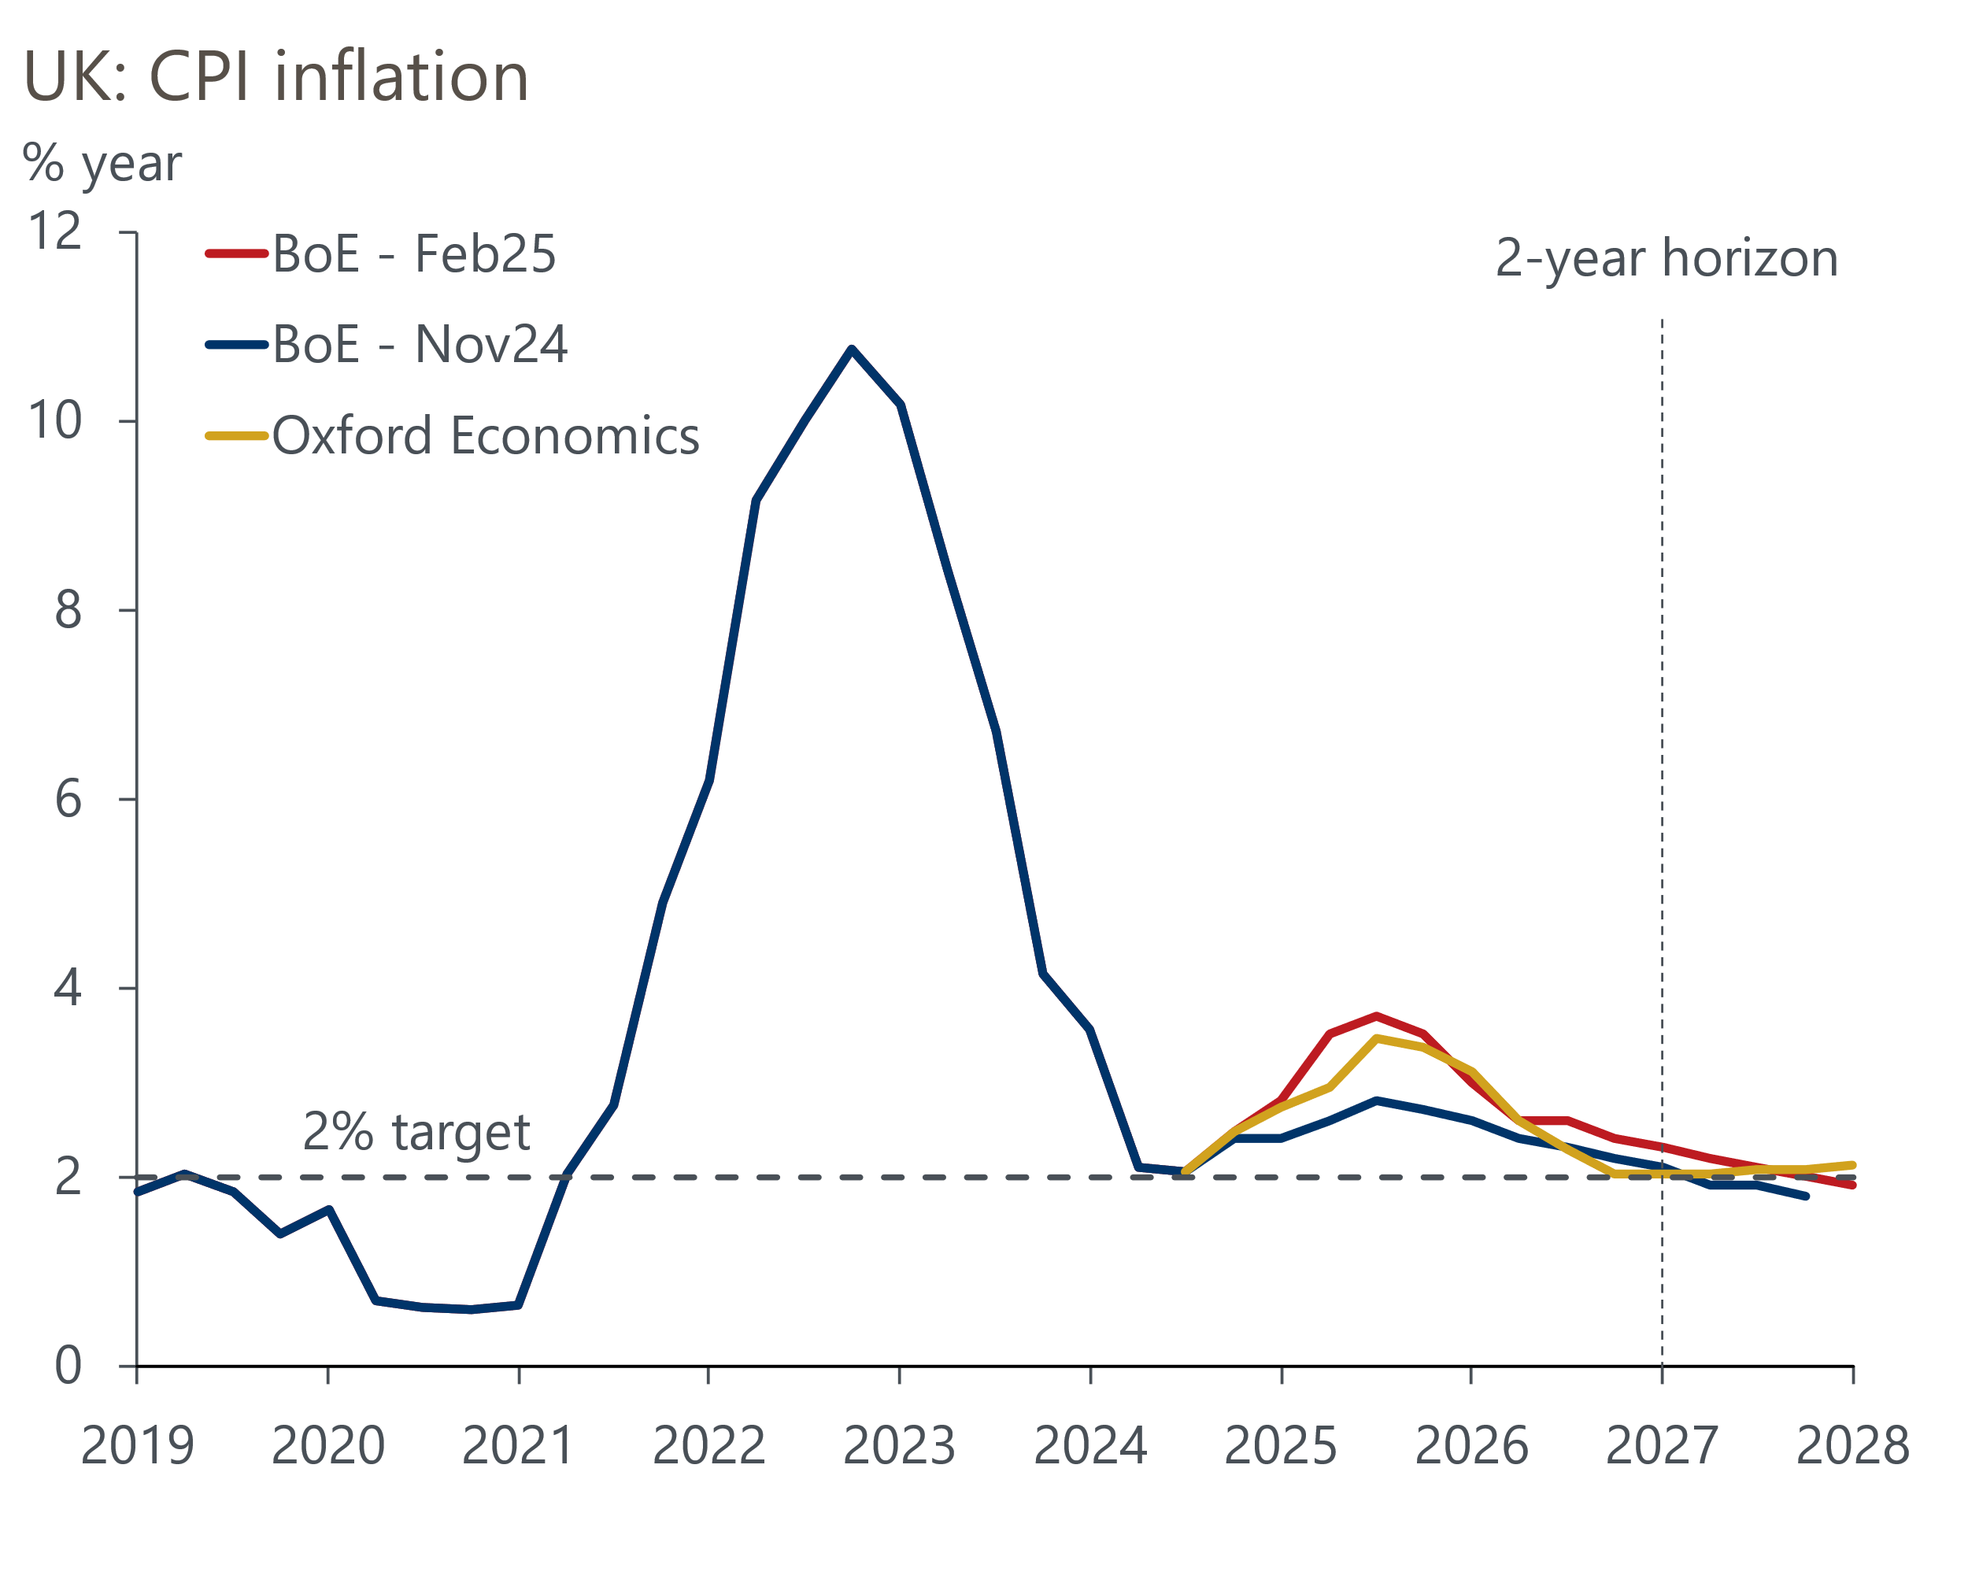
Sources: Oxford Economics, Bank of England Monetary Policy Report
The MPC's new medium-term inflation forecast was based on a market curve 40bps-50bps higher than in November and showed only two 25bp cuts fully priced for this year. We had expected this to lead the MPC to produce a forecast that showed inflation below the 2% target at the two-year horizon, signalling that rates were likely to be cut by more than markets anticipated. This would have been consistent with the relatively dovish messaging on the growth-inflation trade-off from December's meeting.
However, the BoE's new forecast shows inflation at 2.3% in two years' time, only getting to 2% towards the end of the third year. Moreover, the forecast based on unchanged interest rates shows inflation in line with the 2% target after two years, which at first glance could imply no more cuts are needed.
The MPC's message appears to be that persistently poor supply-side performance means the growth-inflation trade-off has worsened, reflecting low potential growth, plus greater stickiness in pay rises and risks that above-target near-term inflation will keep pay growth above a target-consistent pace. This means that a period of weak GDP growth will be required to get inflation back to target on a sustained basis. This leans towards the more hawkish of the three inflation scenarios that the MPC has previously presented, as was made clear in the minutes.
Overall, today's meeting offered general guidance that interest rates are likely to fall further, but the MPC didn't attempt to steer market expectations strongly either way. Though the Committee stuck to its guidance that it will likely loosen policy "gradually", it added the word "careful" to highlight the degree of uncertainty over the economic outlook. The minutes also emphasised that the risks around the outlook for growth and inflation were two-sided.
One way of reading the MPC's communications is that it's trying to stress that the 'cut-hold' tempo that's been established over the past six months shouldn't be taken as given, and there is some jeopardy at every meeting. But we still think a continuation of this pattern is the most likely outcome. So we maintain our baseline forecast that the MPC cuts by 25bps in May, August, and November, leaving Bank Rate at 3.75% at the end of the year.
We still consider the risks to our forecast to be skewed towards Bank Rate being cut faster in response to growth remaining weak. Still, the BoE's new growth forecast is quite cautious, so the bar to faster cuts is set relatively high and would probably require GDP to fall in H1 2025, or inflation to undershoot their forecasts.
Finally, the Monetary Policy Report contained a box on the long-run equilibrium interest rate, R*. The MPC's last assessment in 2018 had estimated that R* was 2.25%. Though the BoE didn't offer its view on the current level of R*, the box cited empirical evidence that suggested R* has risen by 25bps-75bps. Measures derived from financial markets point to a rise of about 90bps, and survey-based guides point to a slightly bigger rise.
All these measures suggest that monetary policy is restrictive now and that a neutral rate is below 4%, with these estimates offering a range of roughly 2.5%-3.75%. This is broadly consistent with our own research, which is more like the BoE's structural models than measures derived from financial markets and surveys. We currently think that Bank Rate will eventually settle at around 2.5%, but it will take a while to get there.

Key passages from the MPC minutes
“Seven members preferred to reduce Bank Rate to 4.5% at this meeting, on the basis that there had continued to be sufficient progress on disinflation in domestic prices and wages. There was a range of views underlying these members’ outlooks for the economy, with various risks around both the domestic and global environment.
On one view, looking through the expected near-term pickup in CPI inflation, the disinflation process had remained on track, and weakening activity and a looser labour market could weigh further on inflation. There was increased uncertainty around both the UK and global economic outlooks, with potentially countervailing forces acting on the prospects for domestic inflation. This warranted an approach to policymaking which was both gradual in continuing to lean against the persistence in inflation and careful in recognising increased uncertainty and that there were two-sided risks to inflation.
On another view, the upside news in indicators of pay growth and inflation over recent quarters, in parallel with continued weakness in activity, was symptomatic of constrained supply relative to demand. In large part, this reflected tepid productivity growth, which was unlikely to recover significantly over the forecast period. On this basis, weakness in observed activity and employment going forward could continue to reflect constrained supply rather than an accumulation of economic slack. This view continued to warrant a cautious and gradual removal of monetary policy restriction."
Our interpretation: There's clearly a wide range of views among the seven members voting for a 25bps cut, with some more concerned about weak demand and others putting more emphasis on weak supply. This divergence of views is likely to be a factor in the MPC's struggle to come up with a strong core narrative.
"Two members preferred a 0.5 percentage point reduction in Bank Rate, to 4.25%, although they had different views on inflation dynamics, the structural factors underpinning them, and future monetary policy. Disaggregated data pointed to inflation continuing to decline through both wage and price-setting channels. The prospect of weak activity and lower labour demand was likely to reduce wage pressures as well as moderate firms’ pricing power. For one member, a more activist approach at this meeting would give a clearer signal of financial conditions appropriate for the United Kingdom, even as monetary policy would need to remain restrictive for some time to anchor inflation expectations, and Bank Rate would likely stay high given structural persistence and macroeconomic volatility. For the other member, the subdued outlook for demand remained consistent with CPI inflation staying sustainably at the target in the medium term despite the expected near-term uptick in regulated prices, and Bank Rate needed to account for policy transmission and supply capacity over the medium term."
Our interpretation: The member looking to send a signal to financial markets is clearly Catherine Mann, with Swati Dhingra being concerned about subdued demand. Mann's volte-face is particularly surprising given her earlier hawkishness. It's not clear what's happened in recent months to trigger her sudden vote switch. Equally, the fact that she explicitly voted for a larger cut as a signalling device and continued to argue for Bank Rate to remain high means that it's very hard to predict what she will do next.
"Based on the Committee’s evolving view of the medium-term outlook for inflation, a gradual and careful approach to the further withdrawal of monetary policy restraint was appropriate.
In addition to the risks around inflation persistence, there were also uncertainties around the trajectories of both demand and supply in the economy that could have implications for monetary policy. Should there be greater or longer-lasting weakness in demand relative to supply, this could push down on inflationary pressures, warranting a less restrictive path of Bank Rate. If there were to be more constrained supply relative to demand, this could sustain domestic price and wage pressures, consistent with a relatively tighter monetary policy path.
The Committee would continue to monitor closely the risks of inflation persistence and what the evolving evidence might reveal about the balance between aggregate supply and demand in the economy. Monetary policy would need to continue to remain restrictive for sufficiently long until the risks to inflation returning sustainably to the 2% target in the medium term had dissipated further. The Committee would decide the appropriate degree of monetary policy restrictiveness at each meeting."
Our interpretation: In previous months, the minutes had presented much simpler and more concise forward guidance. That three paragraphs were required in February appears indicative of the range of views on the Committee and the degree of uncertainty around the outlook. The two-sided nature of the risks was quite surprising in the context of the relatively dovish minutes of December's meeting.

